**Topic:** How long does Ativan Stay in your System in 2022 – Vigoursoul

**Focus keyword:** How long does Ativan Stay in your System?

**Meta Title:** How long does Ativan Stay in your System in 2022 – Vigoursoul

**Meta Description:** How long does Ativan stay in your system, and read about warnings and things to avoid when taking it.

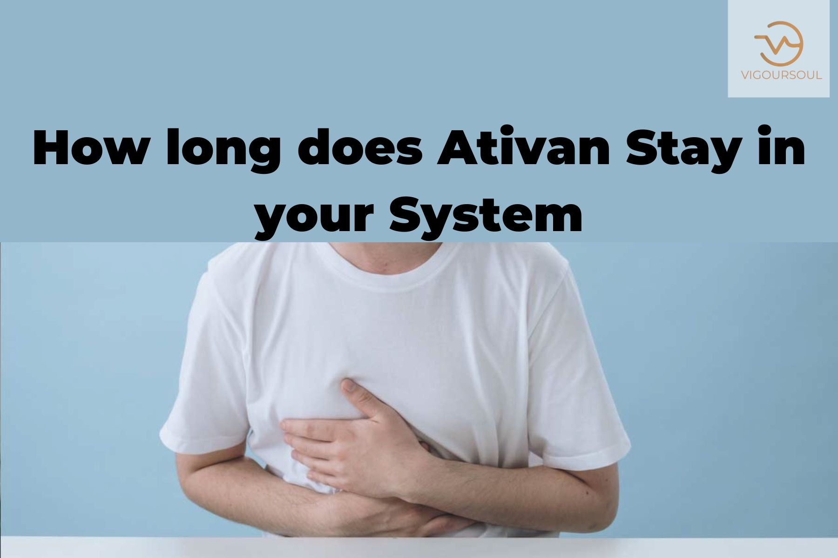

[Ativan](https://en.wikipedia.org/wiki/Lorazepam) is a brand name for the benzodiazepine medication lorazepam. Lorazepam is a benzodiazepine medication that is most typically used to treat clinically significant anxiety concerns and as an anesthetic or anesthetic, but it may also be used to treat seizures, as a sleep aid, and to treat withdrawal symptoms from alcohol or other benzodiazepines.

**What is Ativan (lorazepam)?**

Ativan is a powerful and quick-acting medication used to treat anxiety disorders. Ativan, also known as lorazepam in the pharmaceutical world, is a benzodiazepine medication that acts by rapidly increasing the availability of gamma-amino butyric acid (GABA) in the brain. GABA increases have a soothing effect on the central nervous system. This has a calming impact on both the mind and the body.

Under the Controlled Substances Act, the Drug Enforcement Agency (DEA) classifies Ativan as a Schedule IV controlled substance. This means that, like other benzodiazepines, the DEA considers Ativan to be a drug of abuse.

**Table of content**

**How Long Does Ativan Stay in Your System?**

Urine: Up to six days

Blood: Up to three days

Saliva: Up to 8 hours

Hair: 30 days or longer

**How long does Ativan stay in your urine?**

Depending on the dosage and duration of administration, Ativan is excreted in the urine for one to six weeks. Ativan can be detected in urine screening tests up to six days after the last usage. In persons who have been using the medication consistently or at greater dosages, this detection window may be slightly longer. If testing searches for the metabolite lorazepam-glucuronide, which is formed as the medication is broken down by the body, detection may take place up to nine days after the last usage.

**How long does "generic" Ativan stay in your system?**

Ativan has a half-life of around 12 hours, and because it takes five half-lives for a medication to exit your system, it will take about 60 hours (5 days) to leave your system.

**How Long Does Ativan Last?**

* While clonazepam is a fast-acting medication, it has a comparatively extended half-life. 3 Clonazepam has a half-life of 12 hours, which means that its concentration in the body reduces by half every 12 hours.
* The medicine is largely processed by the liver and subsequently removed from the body by the kidneys via urine. Ativan can be detected up to nine days after the previous usage.
* If you are going to be doing a urine drug check for employment or other purposes, be advised that it will test positive if you are using Ativan. Provide your prescription to the testing facility so that the findings may be interpreted correctly.

**Blood:**

Blood tests can identify Ativan for the first time six hours after administration. Blood testing can also identify the drug three days after consumption. However, this detection window may be extended in situations when patients have been taking Ativan at greater doses for three days or more.

**Urine:**

Ativan is excreted in the urine for one to six weeks, depending on the dosage and duration of administration. Ativan can be detected in urine screening tests up to six days after the last usage. In persons who have been using the medication consistently or at greater dosages, this detection window may be slightly longer. If testing searches for the metabolite lorazepam-glucuronide, which is formed as the medication is broken down by the body, detection may take place up to nine days after the last usage.

**Hair:**

Ativan, like other medications, may be found in hair samples for far longer than other procedures. A hair test can identify it for up to 30 days after use.

**Saliva:**

Saliva tests have indicated that Ativan might be detectable in samples for up to eight hours after usage. Saliva tests, on the other hand, are rarely used to screen for benzodiazepines like Ativan.

**How to Get Ativan Out of Your System?**

* Ativan has a rather lengthy half-life. Like other benzodiazepines, its usage can develop to physical dependency and to withdrawal symptoms when you stop taking the medicine.
* If you do decide to discontinue taking Ativan, please talk to your doctor first. Due to the danger of severe withdrawal side effects, you should only discontinue clonazepam under the guidance of a medical practitioner.
* Once you have safely stopped taking Ativan, there may be a few things that you may do to speed up how soon the medicine entirely clears your system. Because Ativan is eliminated through urine, remaining well-hydrated by drinking enough of fluids may somewhat boost how quickly the medicine is cleared from your system.

**Ativan and Irritable Bowel Syndrome:**

Irritable bowel syndrome is a surprise application for Ativan (IBS). Doctors may prescribe the medication to IBS patients if anxiety is a cause for their symptoms. IBS has no cure; nevertheless, lessening an individual's worry lessens the bad symptoms linked with it. If the person being treated has a history of substance dependence, medical practitioners may avoid using Ativan.

**Ativan Abuse:**

As a Schedule IV substance, the DEA considers Ativan to be a drug of abuse. Taking Ativan for any length of time might result in both physical and psychological dependence. Those with a history of alcoholism or mental health difficulties are more prone to develop an Ativan addiction.

**Ativan Addiction:**

Because Ativan is addictive, people who use it may develop physical dependence and withdrawal symptoms. Ativan addiction makes it difficult for someone suffering from a substance use disorder to cease using the medication, even when there are difficulties linked with it, such as:

* Concerns for family and friends
* Failure to fulfill duties at work, school, or home
* Putting oneself in perilous situations
* Loss of interest in formerly important items to the individual
* Social isolation from friends and coworkers
* Financial issues

Those who have a long history of Ativan addiction may develop a tolerance to the medication. When a person consumes a drug on a regular basis for a long enough period of time, a greater dose is required to obtain the same results. Building a tolerance to Ativan can put a person battling with substance misuse at risk of overdoes.

**Ativan Overdose:**

Ativan overdose is possible at any dosage higher than what your doctor has prescribed for you. The same advice applies to anyone taking a variety of prescription medicines.

Benzodiazepine overdoses can be intentional or unintentional. In either scenario, it is critical to understand the signs and symptoms of an Ativan overdose. These are some examples:

* Lethargy and fatigue
* Incoherent behavior
* Sweating excessively
* Memory lapses
* Reduced organ function (liver impairment)
* Sedation of the central nervous system causes fatal respiratory depression (possibly leading to heart attack, coma, or death)

If you or someone you know is suffering any of these symptoms, it is critical that you get expert medical help right once. Call 911 as soon as possible to talk with a medical practitioner. The sooner a medical professional can reach the individual, the less probable it is that they will suffer from health problems.

**How Long Does It Take to Feel Effects?**

* Benzodiazepines, such as Ativan, have sedative and hypnotic properties.  The medicine works by amplifying the effects of GABA, a natural neurotransmitter that depresses the central nervous system (CNS), resulting in a soothing or relaxing effect.
* Ativan can be administered orally, as a liquid concentration, or intravenously. The various routes have varying timelines for when they go into action. With pills or liquids, the peak effects are visible in two hours.
* The effects of an Ativan injection begin in 15 to 30 minutes and persist for 12 to 24 hours.

**Symptoms of Overdose :( How long does Ativan Stay in your System)**

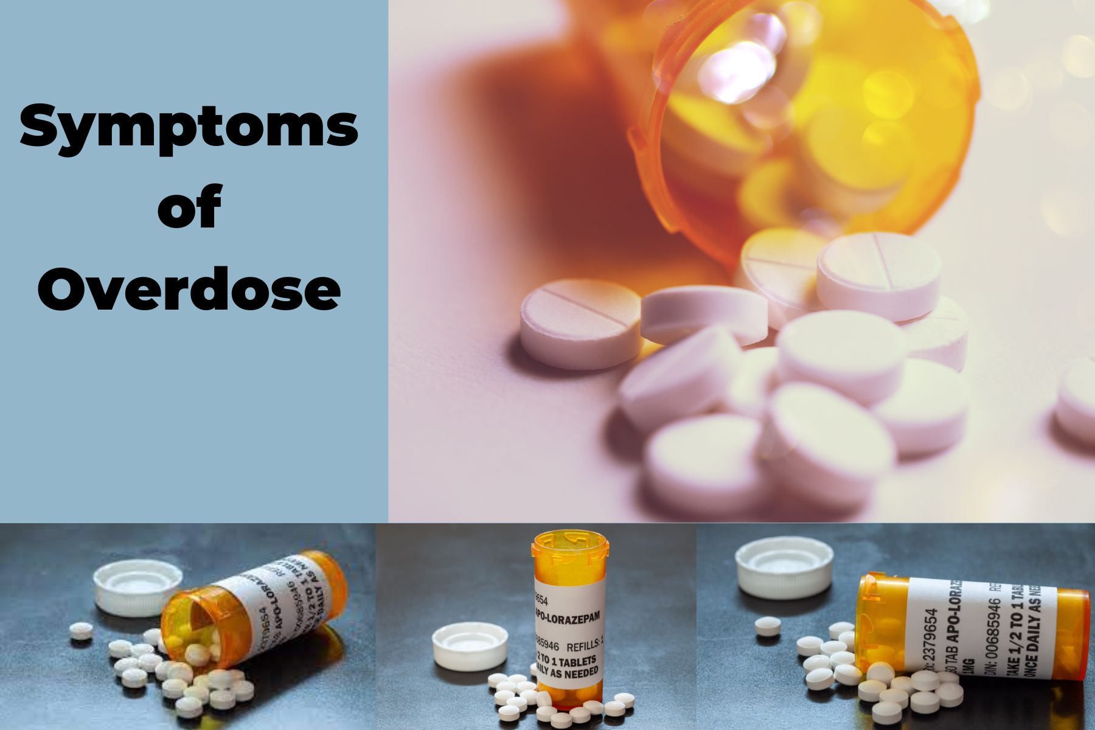

 Overdoes with Ativan are more prevalent when combined with alcohol or opiate drugs such as Vicodin (hydrocodone) and OxyContin (oxycodone).  This combination may be fatal, so make sure your family or household members know what signs to look for so they can receive emergency treatment as soon as possible.

Call 911 immediately if you believe someone has overdosed on Ativan. The indicators of an Ativan overdose include:

* Unusual vertigo
* Light-headedness
* Extreme drowsiness
* Breathing trouble or slowed
* Unresponsiveness

**How Long Does Ativan Remain in the Body?**

Individuals being tested for drug usage may or may not be screened for benzodiazepines, depending on the circumstances. Many traditional drug screens (for example, the SAMHSA 5 Panel Test) may not find benzodiazepines, although more comprehensive screenings (for example, the SAMHSA 10 Panel Test) will.

There are predicted detection windows for how long Ativan will appear on a drug test based on published data.

* Clonazepam can be detected in urine for up to six days, and some metabolites can be detected for even longer (nine days). If clonazepam is consistently misused, urinalysis may indicate the presence of the drug after a week or more.
* According to research, blood samples can detect the presence of lorazepam for up to three days.  
  Hair samples may identify the presence of lorazepam up to 30 days after intake.
* Typically, the medication will not test positive in a hair sample for several days after the individual has taken it.
* Saliva tests can detect the presence of Ativan up to eight hours after use.

**Ativan and Alcohol :( How long does Ativan Stay in your System)**

Regardless of how long Ativan remains in your system, drinking alcohol while using it is harmful. It is not suggested that anyone taking Ativan consume alcohol, even in little amounts. The following are the risks associated with mixing the two substances:

Because both medications are depressants, they enhance the effects of the other. Slowed breathing, excessive sleepiness, coma, and death can result from this.  
The acute tiredness and loss of motor function caused by taking Ativan with alcohol can have an effect on decision-making. This raises the likelihood of an individual putting oneself in danger.

**Precautions: (How long does Ativan Stay in your System)**

When you combine Ativan with alcohol or other drugs that might depress respiration, you run the risk of major respiratory issues, sedation, or coma. To avoid an unintentional overdose or other complications:

* Do not consume alcohol when taking Ativan.
* Do not use any street drugs since they may include compounds that impair respiration.
* If you are nursing, be warned that this medication goes into your milk and may harm your child.
* Consult your doctor if you are pregnant or want to become pregnant.
* Avoid Ativan if you are depressed or have suicide thoughts.
* If you are older, you may encounter more Ativan side effects, such as sleepiness.
* Do not smoke cigarettes or use tobacco products, since these might diminish the benefits of Ativan.
* If you are taking or intend to use any opiate or opioid drugs, see your doctor since they might cause a life-threatening response with Ativan. Medication containing codeine or hydrocodone (for coughing or pain), fentanyl, hydromorphone, Demerol, methadone, morphine, oxycodone, and tramadol are examples.

**Ativan Addiction Treatment :( How long does Ativan Stay in your System)**

Addiction is a medical condition. Treatment with Ativan or other medications is commonly available. Understanding how underlying mental health issues and behavioral health conditions can be the driving force behind addiction is a critical component of addiction treatment. Therapeutic clinics employ a variety of treatment methods, including:

* CBT stands for Cognitive-Behavioral Therapy.
* Therapy through experience
* Medication administration
* Detox

**How long does Ativan Stay in your System FAQS**

**How does Ativan make you feel the next day?**

Ativan can have a significant impact on the brain and nerves. Many users, however, report "rebound" side effects, or worsening of the symptoms that the medicine is intended to cure. Ativan, in particular, might produce rebound anxiety, sleep disruptions, odd body movements, and agitation.

**When is the best time to take Ativan?**

A dose of 1 to 2 mg administered at bedtime is commonly prescribed for sleeping problems (insomnia) caused by anxiety. The usual dose of Ativan before surgery is 2 to 4 mg the night before surgery. A second dose of 2 to 4 mg may be administered 1 to 2 hours before surgery. The elderly may require a lower dose.

**What does Ativan do to the brain?**

Lorazepam is a benzodiazepine that works in the brain to alleviate anxiety symptoms. Benzodiazepines are CNS depressants, which are medications that slow down the nervous system.

**Conclusion :(How long does Ativan Stay in your System)**

The bulk of Ativan is removed within five days of administration; however, some lorazepam metabolites (substances formed as a result of drug breakdown) may persist in a person's system for longer than a week.